**JENKINS PIPELINE**

**Jenkinsfile :**

*node{*

*def docker = tool name: 'docker', type: 'org.jenkinsci.plugins.docker.commons.tools.DockerTool'*

*def dockerCMD = “${docker}/bin/docker”*

*stage('git checkout'){*

*git 'https://github.com/bhar-subhajit/cicd-pipline-bootcamp.git'*

*}*

*stage('build and test'){*

*def mavenHome = tool name: 'maven-3', type:'maven'*

*def mavenCMD = "${mavenHome}/bin/mvn"*

*sh "${mavenCMD} clean package"*

*}*

*stage('docker build'){*

*sh “${dockerCMD} build -t subhajit1996/java-app:1.0.0 .”*

*}*

*stage('push docker image to docker hub'){*

*withCredentials([string(credentialsId: 'dockerHubPassword', variable: 'dockerHubPwd')]) {*

*sh "${dockerCMD} login -u subhajit1996 -p ${dockerHubPwd}"*

*}*

*sh “${dockerCMD} push subhajit1996/java-app:1.0.0”*

*}*

*stage('run docker image'){*

*sh “${dockerCMD} run -p 8888:8080 -d subhajit1996/java-app:1.0.0”*

*}*

*}*

**Jenkins Pipeline: Groovy script ran successfully:**

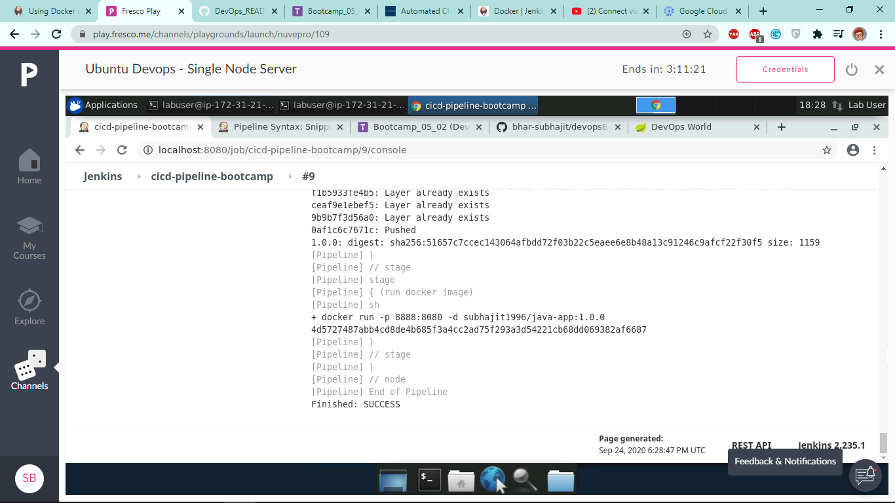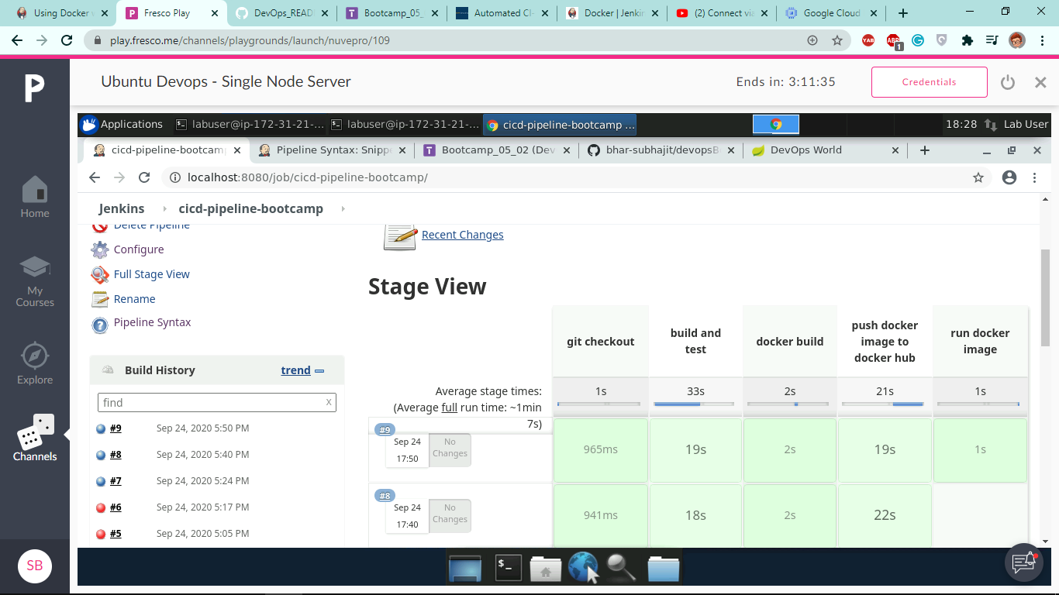

**SSH Connection to GCP instance:**

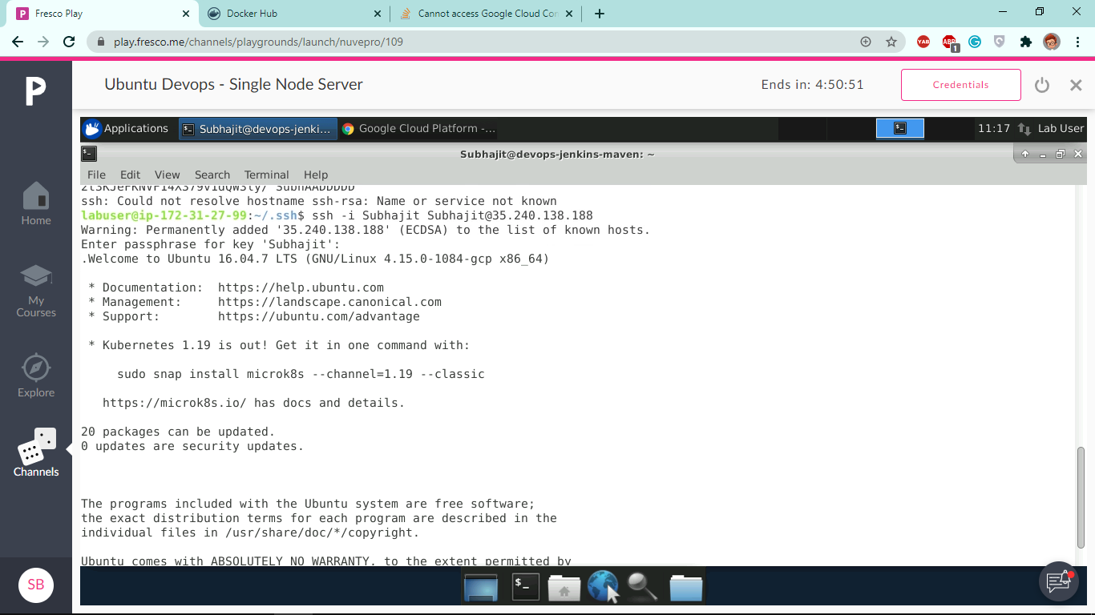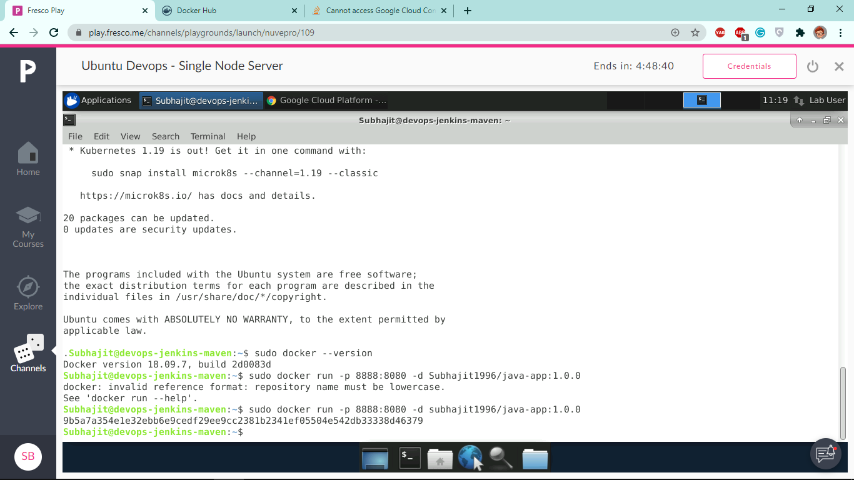

**Docker Image Running Successfully on GCP Instance:**

